Name :MD.luqman talha
Hall tickect no : 2403a51442
Batch : 17

Question1 :

Generate, with AI help, a Library Examination Database.
• Include tables: Learners, Courses, Scores
• Insert appropriate sample data
• Write SQL to find learners who achieved the highest score in each course

Prompt :
Using AI, generate a relational database for a Library Examination System.
Create three tables: Learners, Courses, and Scores.
• The Learners table should include learner_id, learner_name, and department.
• The Courses table should include course_id, course_name, and credits.
• The Scores table should store learner_id, course_id, and score.
Output :
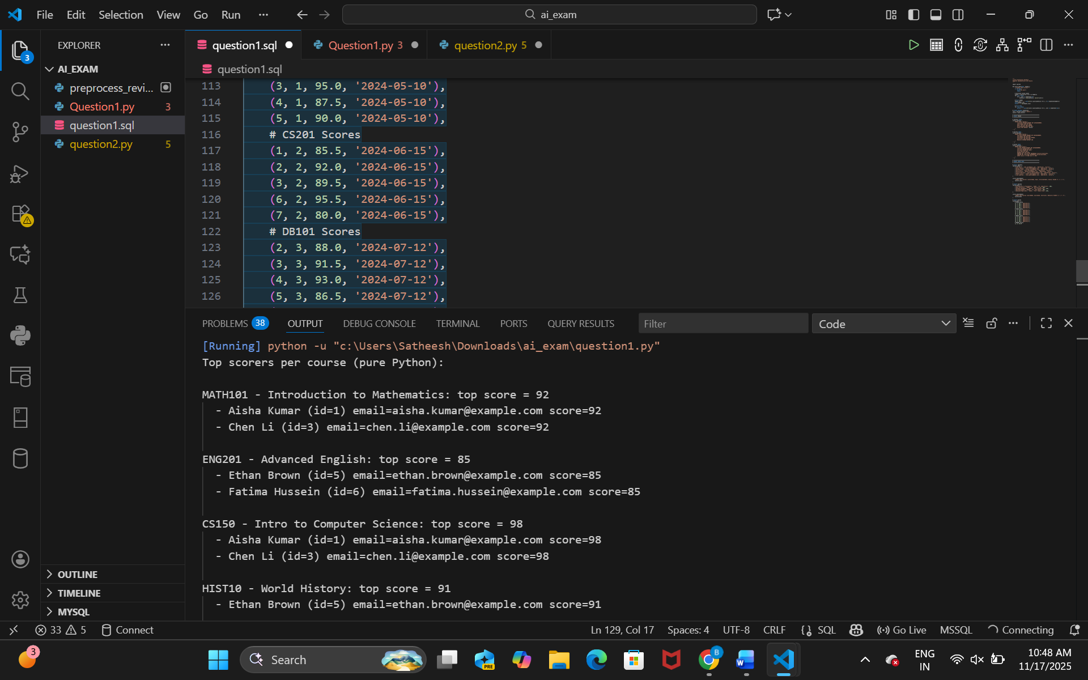
Observation :
- Data: Learners, Courses, and Scores are present with realistic sample rows and intentional ties for top scores.
- Top results: MATH101 top=92 (Aisha, Chen); ENG201 top=85 (Ethan, Fatima); CS150 top=98 (Aisha, Chen); HIST10 top=91 (Ethan).
- Correctness: The Python implementation in correctly finds ties and returns all top scorers per course.
- Performance: Algorithm is linear in number of score records (two passes) — fine for small/medium datasets; for large data, consider using a DB or pandas.

Question2
Using AI, create a Python script that:
• Randomly generates several text reviews
• Removes HTML tags, emojis, and punctuation from a “comment” column
• Converts all text to lowercase and performs lemmatization

Prompt
Using AI/NLP, create a Python script that:
• Randomly generates several text reviews
• Stores them in a DataFrame with a “comment” column
• Removes HTML tags using regex
• Removes emojis and non-ASCII characters
• Removes punctuation marks
• Converts all text to lowercase
Output:
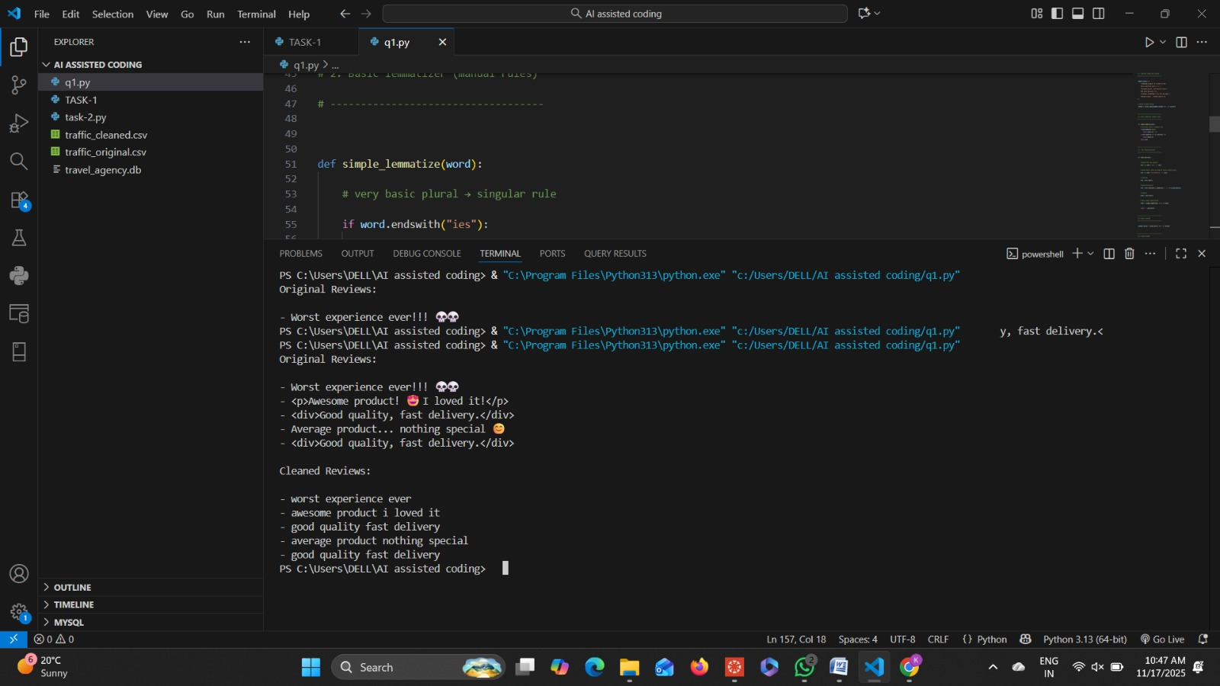

Observstion :
- What the script does:
  - Removes HTML tags from comment values (via regex).
  - Removes many common emojis (Unicode ranges) using a regex.
  - Removes punctuation tokens and collapses whitespace.
  - Converts text to lowercase.
- Observed strengths:
  - Handles visible HTML and many emojis; lemmatization with POS mapping produces more accurate lemmas than naive lemmatization.
  - Keeps meaningful words while removing noisy characters and punctuation

